**Lab-9**

**A-1**

**1) Image collection and sentimental analysis based on the image tags using Instagram streaming (related to your project)**

**a. Training Datasets: Instagram Streaming/Categorized Image (e.g., Static UEC Food Dataset) and metadata**

**b. Testing Datasets e.g., Image, UserGroup, Category, Rating (Instagram streaming)**

* We have collected the image datasets from the Instagram. We have collected the Image data for the hashtags body wearing cosmetics.
* The list of tag categories are List("shirt","shoes","hats","glasses","watch","wallet")
* Along with the Training data collection we have also collected the image tags based on user group and their image links and tags in Recommendation.txt file which is later used for the Recommendation. Format “username;caption;tag;tagId;link”

1. 1. We have collected the image datasets from the Instagram. We have collected the Image data for the hashtags.

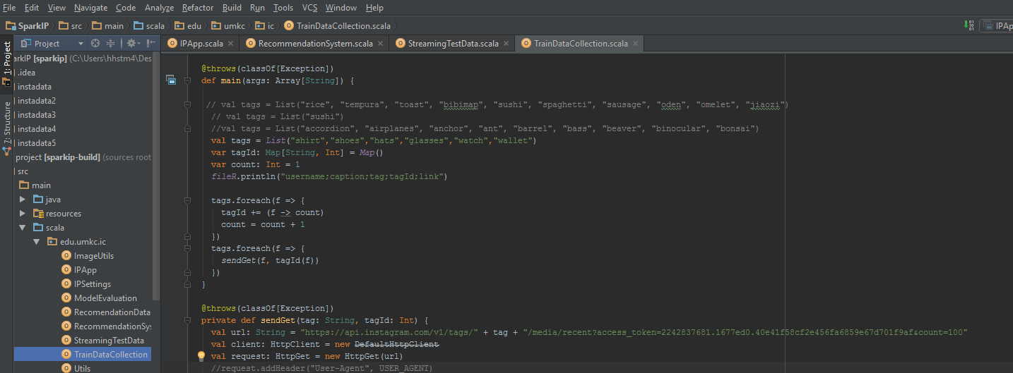

1. For Testing and Validation of the model we create a live streaming data to predict the current live image for the particular tags. We open a socket to listen the request from the client i.e. our classification model.

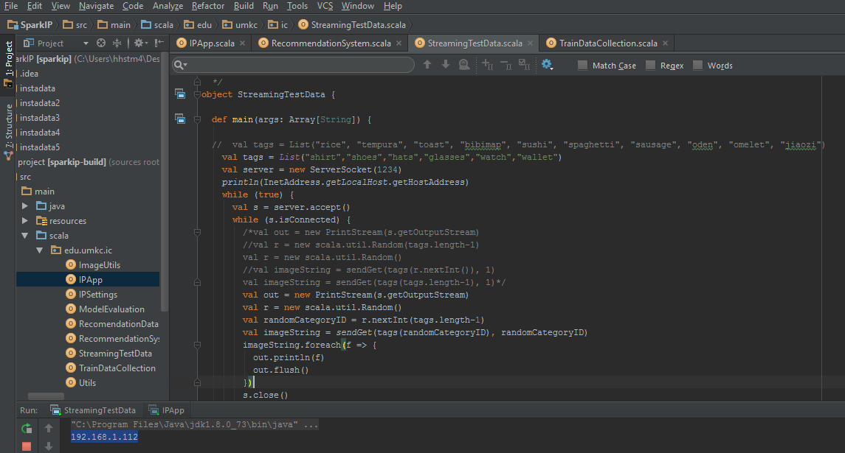

**2) Image Classification based on the categories related to your project**

Image classification:

Predicting the tag for Live Image Data

First, we created the model for training data as shown in below figure.

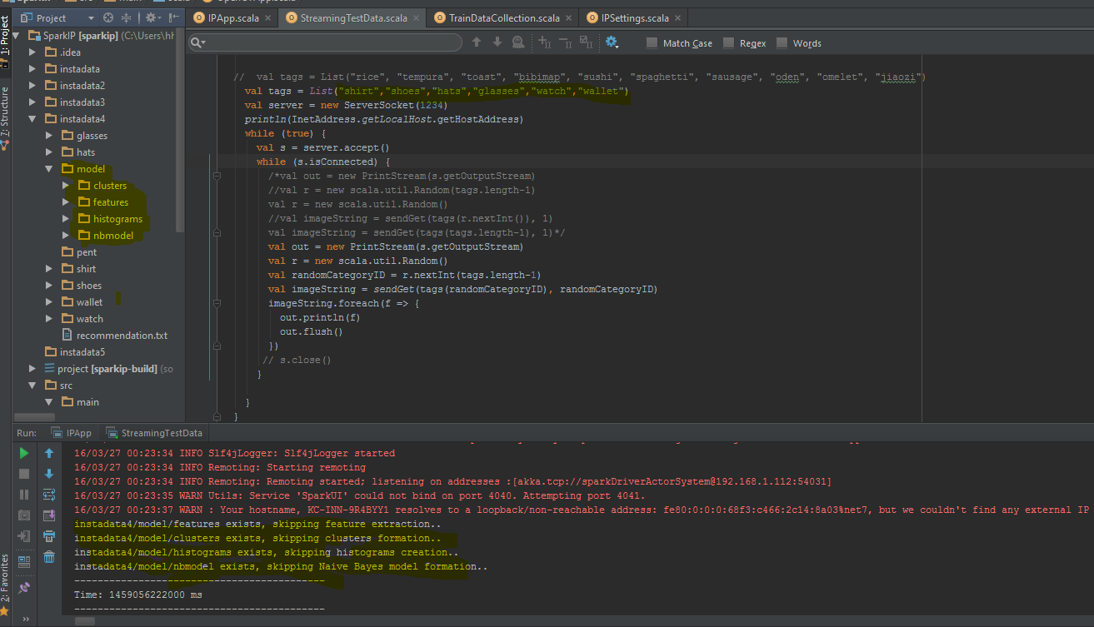

Then we have run the same program to predict the upcoming stream to classify it into the category.

**3) Image-based Recommendation system (related to your own project)**

**a. The rating based on sentiment analysis of Instagram metadata**

**b. Expected outcome is to make a recommendation based on user image input or profile (e.g., preferences, location, gender, age)**

We have recommended the top wearing style for the user.

We have assigned userId based on the alphabets.

We have collected recommendation.txt with "username;caption;tag;tagId;link"

We have used the user preference with UserId,TagId,SentimentRating

